Instructions:

* Replace the highlighted areas in yellow above with your own name, section and group numbers and correct dates,
* Watch the corresponding lab demo videos, review related materials in lecture notes, lab manual and other related documents,
* Provide your best answers to the following questions. Add pages as needed,
* Convert this Word answer sheet into pdf format and submit to Canvas.

1. Review Week 4 lecture materials and MIL-R-47196A standard thoroughly.
2. (80 pts) A pre-specified design of 2-2 rivet pattern is given in Fig. 1 for a riveted sample consisting of two overlapped 2” by 8” test panels. The thickness of each test panel is 0.025” and hole diameter (i.e. rivet diameter) is 1/8”. Your first task of the prelab is to evaluate the test panel’s joint efficiency for each of the four failure modes as described in Week 4 lecture notes, particularly in the workout example on pages 18-28. Which failure will happen first and why? Next, for each failure mode, predict the maximum load that can cause that type of failure. For tension failure mode, calculate the maximum load and corresponding stress for each row separately, as demonstrated in Part 3 of the workout example. Use the material properties provided below.
3. (120 pts) Based on what you find in Section 2. above, redesign the joint for better strength within the same overlapped area. You may want to consider popular rivet patterns such as 1-3-1 and 2-1-2 or higher density like 2-3-2 and 3-3-3. You can use as many rivets as you like but remember that too many rivets can actually weaken the joint (remember the design rule of thumb on page 17 of lecture notes). Calculate the joint efficiency and predict how and under what load your new design will fail in each failure mode, just like what you did in Section 2. You don't necessarily need to follow the minimum pitch and edge margins specified in MIL-R-47196A, but if you do decide to disregard standard practice, you should justify why. You will also need to be able to justify if you will take different approaches in redesigning the joint.

nominal material property values of 2024-O Aluminum alloy for both the test panels and rivets:

Ultimate tensile strength: 27ksi

Ultimate bearing strength: 50ksi

Shear strength: 18ksi

Tensile yield strength: 11ksi

Elongation at break: 20%

Young’s Modulus: 10600ksi

Poisson’s ratio: 0.33

Density: 0.1 lb/in3

Total 200 points

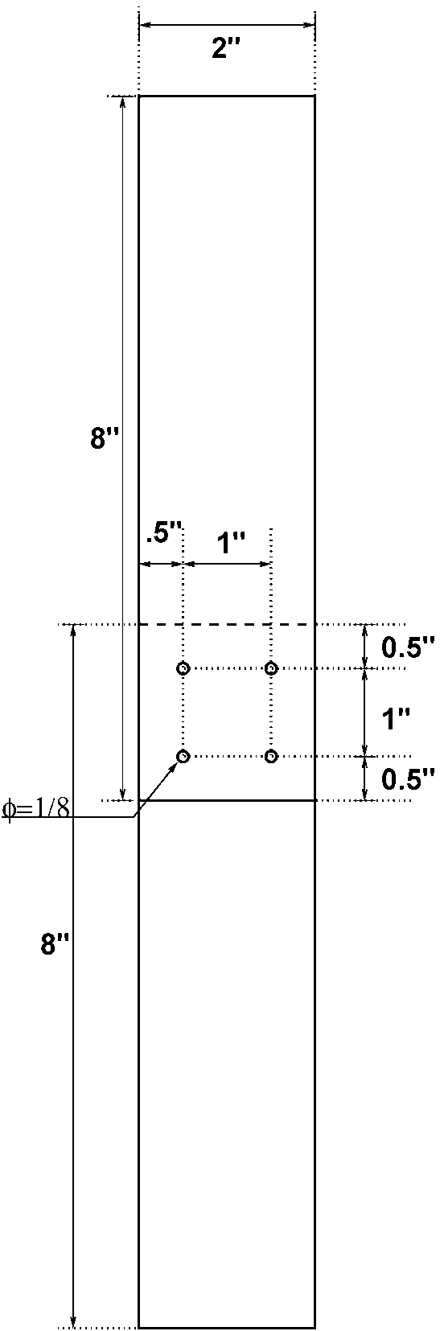

Figure 1: Layout of the pre-specified riveted joint design.

Answers: